**Ice task 7**

--CREATE STORED PROCEDURES FROM ALL THE TABLES WITHIN TUTORAIL SESSIONS DATABASE

--EXTRA

GO

CREATE PROC SPTUTORS0 AS SELECT * FROM TUTOR

EXEC SPTUTORS0;

GO

CREATE PROC SPSCHOOL0 AS SELECT * FROM SCHOOL

EXEC SPSCHOOL0;

GO

CREATE PROC SPSESSIONS0 AS SELECT * FROM SESSIONS

EXEC SPSESSIONS0;

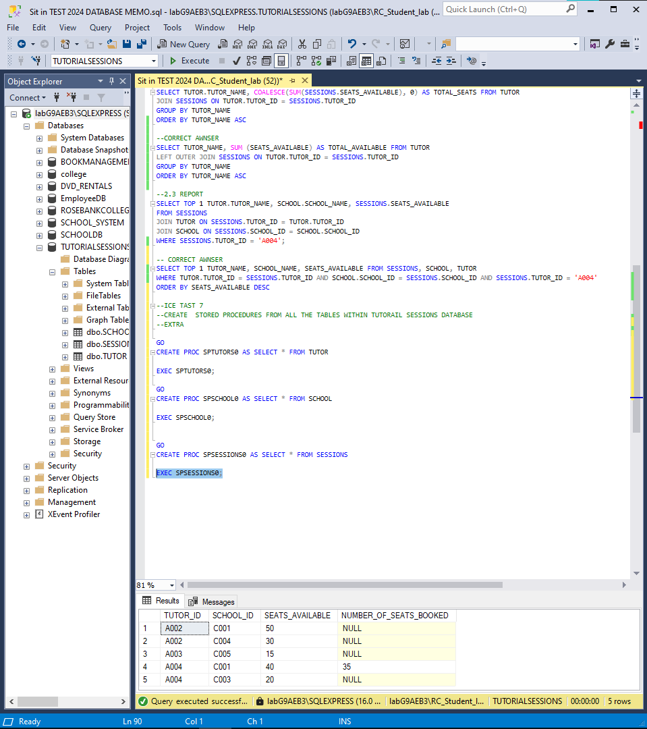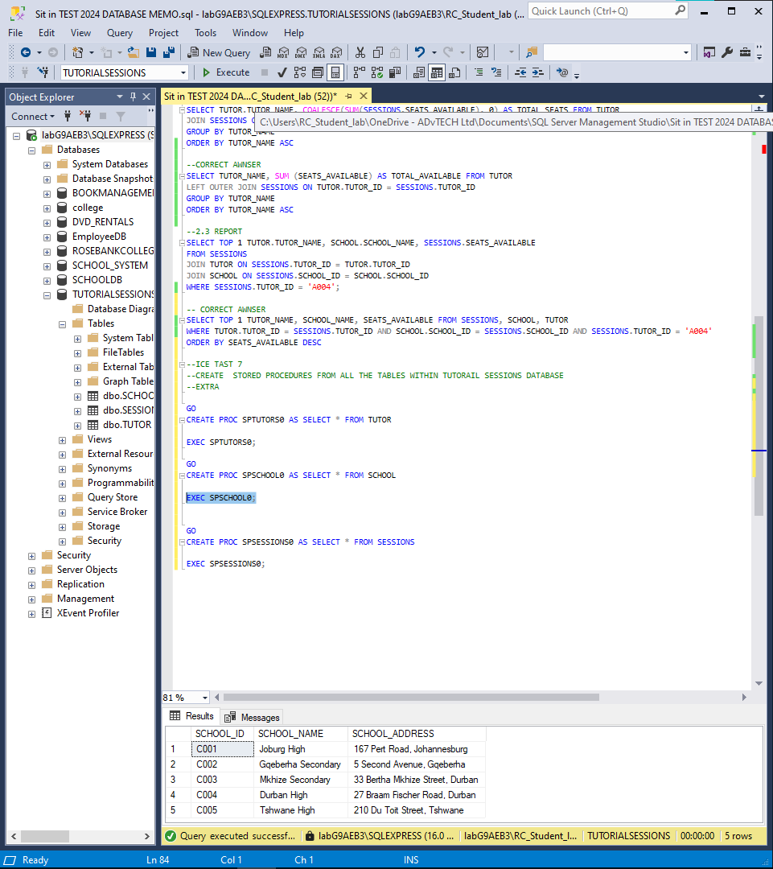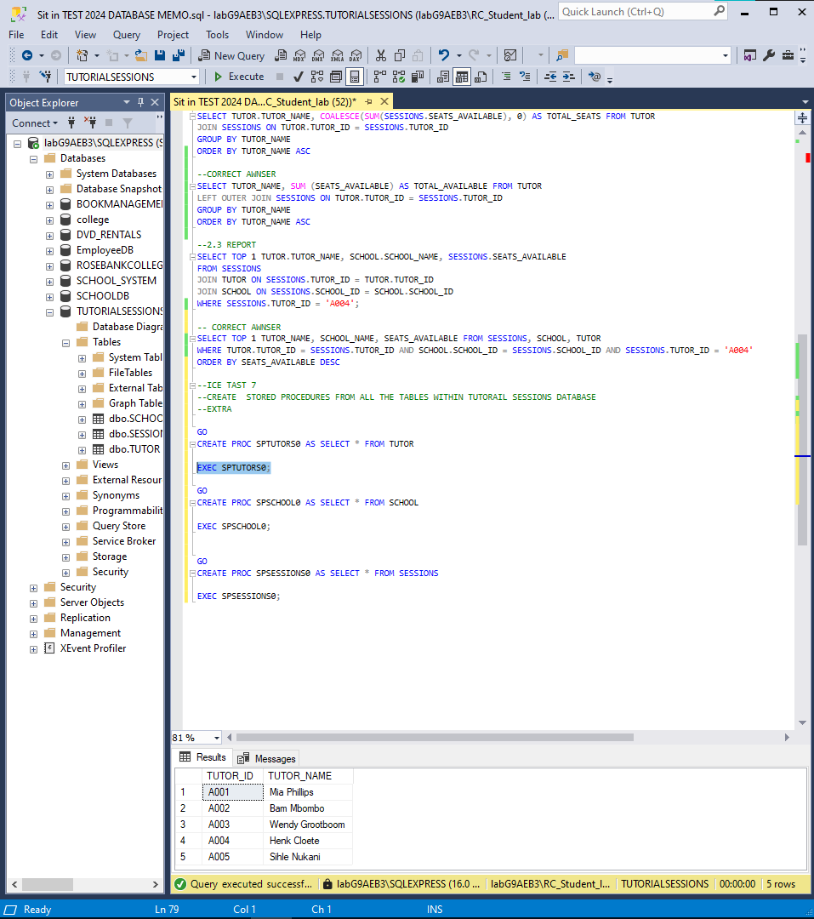

**Reference**

Gido, J. Clements, P.J. Baker, R. 2022. Successful Project Management in South Africa. Second edition. Boston: Congage Learning.